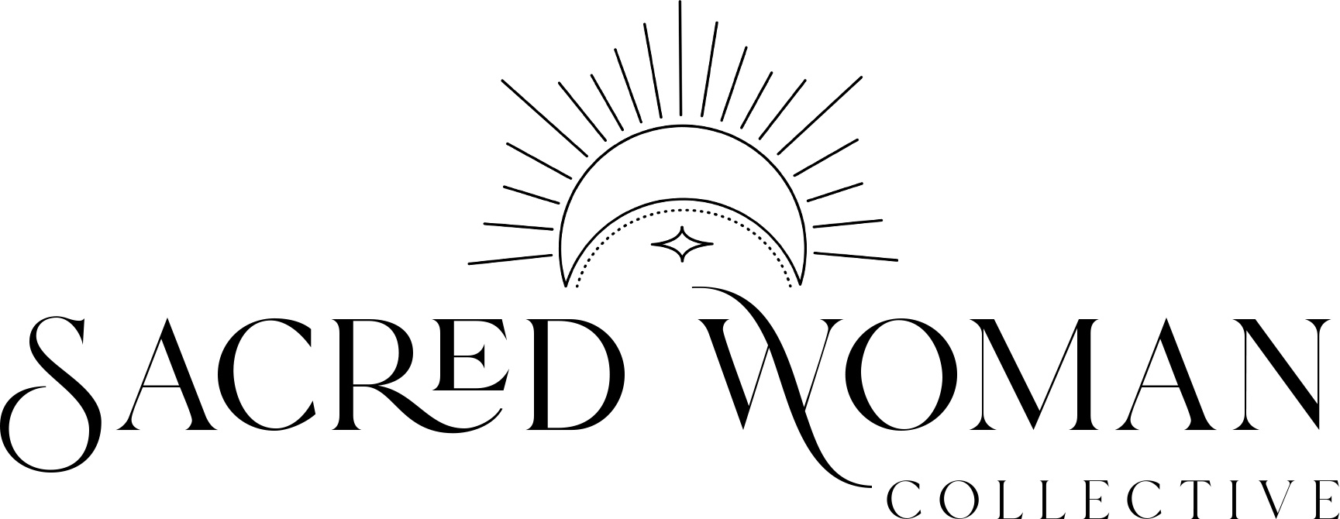
Waiver Release & Terms Agreement
In consideration of my participation in Sacred Woman Collective and associated events and activities (collectively, “Retreats,”) I agree as follows:
1. Definitions. “Activities” include all activities at a Sacred Woman retreat and may include, without limitation, yoga, meditation, breathwork, sacred circle, running, hiking, swimming in pools or ocean, transportation in Released (defined below) or other vehicles, training, classes, instruction, traveling to and from a Sacred Woman Collective retreat and all other activities associated with one or more Retreats. “Risks” shall include, without limitation, vehicular traffic, road and trail conditions, health and environmental conditions (including without limitation disease, infection and animals), weather, equipment failure, driver error, rider error, participant error, food provided, facilities, actions of other people, and the actions, negligence and carelessness of the Released, as defined below. “Released” shall include Sacred Woman Collective, Staci Levine, it’s officers, directors, employees, contractors and agents, volunteers, the owners or operators of any Retreat facilities or equipment provided and the sponsors of Sacred Woman Collective or the retreats.
2. Certification, Acknowledgements and Assumption of Risk. I hereby certify that I am physically fit, am in sufficient for participation in the Sacred Woman Collective retreat and have not been advised otherwise by a qualified medical person. This includes having taken precaution to avoid coming in contact with a Covid-19 infected person, i.e., wearing a mask when in public if asked to do so, and maintaining CDC recommended social distance. I hereby assume all risks of participation in the Activities and the Retreat, including without limitation all Risks, whether such risks are caused (a) by the negligence or carelessness of, or (b) from dangerous or defective equipment or property owned or provided in any way by the Released. I acknowledge that the Retreat is an extreme test of my physical and mental limits and carries with it the potential for serious injury, property loss and even death.
3. Waiver, Release and Agreement Not to Sue. I, and on behalf of my executors, administrators, heirs, successors and assigns, hereby fully release, waive any claims I or they may have against, discharge and agree not to sue the Released or each of them from any and all liability to me or my executor, administrator, heirs, successors and assigns for any and all damage, injury or death of myself or the participant while at, participating in, while in route to or from a Retreat or while participating in the Retreat or any Activities, whether caused by negligence or carelessness of the Released or otherwise.
4. Indemnification and Hold Harmless. I, both on my own behalf and as the parent or legal guardian of a participant of a Retreat, hereby agree to indemnify and hold harmless the Released and each of them from any loss, liability or damage, including reasonable attorney’s fees incurred in any suit, demand or legal action arising out of any alleged injury, damage, Covid-19 or death resulting from engaging in any Activities or participation in any Retreat, whether such injury damage, death is alleged to or did result from the negligence or carelessness of any person.
5. Medical Care. Although I acknowledge that there is no obligation of any person to provide any participant with medical care during, prior to or after a Retreat, in the event medical treatment is provided to me or my child or legal guardian, I hereby consent to such care. Paragraphs 2 through 4 of this waiver and release shall apply to such medical care and such medical care shall be deemed to be an Activity.
6. Personal Property. I acknowledge and agree that I am responsible for my equipment and all personal property during the Retreat and that the Released are not responsible in any way for such property whether it is lost, stolen or damaged.
7. Disasters. I acknowledge that events and occurrences can occur beyond the control of Sacred Woman Collective or the Released that may impact a Retreat and or me. These events and occurrences include, without limitation, fire, wind, hail, snow, hurricanes, tornados, severe rain, flood, smoke, earthquakes, landslides, acts of war, acts of governments, terrorist acts, and loss of electricity and or other utilities (collectively, “Disasters.”) What constitutes a Disaster shall be determined by Sacred Woman Collective in its sole discretion. I further acknowledge and agree that Sacred Woman Collective and the Released shall not be responsible for any injury, loss, damage or expense associated with a Disaster.
8. Words and Images. I understand that during a Retreat I may be photographed, videotaped and/or my words may be recorded, and I authorize and allow Sacred Woman Collective and its sponsors to use such images, words and likenesses for marketing, on websites, in brochures or other writings and any other legitimate purpose.
9. Interpretation and Governing Law. This document shall be construed broadly to provide a release and waiver to the maximum extent permitted under California law. If any portion of this document shall be held as invalid it is agreed that the balance shall continue to be in full force and effect. This document shall be governed by the laws of the State of California, expect with respect to its provisions on choice of law and venue for any legal action shall be in the state or federal courts of California as applicable.
10. Payment Processing
Pricing is per person and varies on a variety of cost factors, with peak travel times being the most expensive. You can always find pricing on the website. Pricing includes retreat costs only; it does not include airfare or travel to and from the retreat (unless noted otherwise). While every effort is made to keep to all published itineraries, we reserve the right to make changes for your convenience. In some cases, weather conditions or “acts of god” (e.g., pandemic) can necessitate an alteration in the event itinerary, such as the dates of the retreat, and this does not constitute any reason for refund.

11. Deposit & Payment Terms
In order to reserve your spot, there will be a non-refundable agreed upon deposit per person. Depending on your booking date and the agreement with the location, there will be a pre-determined balance due date which can be made in one payment or multiple payments depending on time of booking and the date of the event.

12. Cancel Policy
If you wish to cancel your retreat, please contact staci@sacredwomancollective.com immediately. If the retreat is at least 60 days from the date of your cancellation and we’re able to sell your spot, your payments, minus your deposit, will be fully refunded. If you cancel with less than 60 days and we’re able to sell your spot, your funds will be transferred to another event, otherwise there will be no refunds with less than 60 days’ notice. There are no exceptions to our cancellation policy for ANY reason, including weather, health changes, personal emergencies or otherwise. There is no refund for arriving late or leaving a trip early.
SWC is not responsible for any expenses or damages incurred because of a retreat cancellation including preparation costs, airline tickets, travel documents or other expenses. SWC reserves the right to cancel any retreat prior to departure if there are too few people booked, in which case you will be given a full refund of all payments made to SWC. You will not be entitled to claim any additional amounts or seek any compensation for any injury, loss, expenses, or damages (either direct or consequential) or for any loss of time or inconvenience which may result from such cancellation (including but not limited to visa, passport and vaccination charges, or departure, gear purchases, airport and airline taxes).

Printed Name: ___________________________________

Signature: _______________________________________ Date: _______________________ Age: _______________

________________________________________________
Signature of Parent or Guardian (if Participant is under 18 years old)

